Week 2 Data Validation Report
Project: Campus Cultural Fest Operations Dashboard & Process Optimization System
Prepared By: Karthick Raja
Objective
The purpose of this validation exercise was to verify that the generated operational datasets were successfully loaded into SQLite and that relationships between registrations, attendance records, volunteers, tasks, and incidents were logically consistent.
Data Load Validation

Validation Query
SELECT COUNT(*) FROM Events;
SELECT COUNT(*) FROM Registrations;
SELECT COUNT(*) FROM Attendance;
SELECT COUNT(*) FROM Volunteers;
SELECT COUNT(*) FROM Task_Assignments;
SELECT COUNT(*) FROM Incidents;
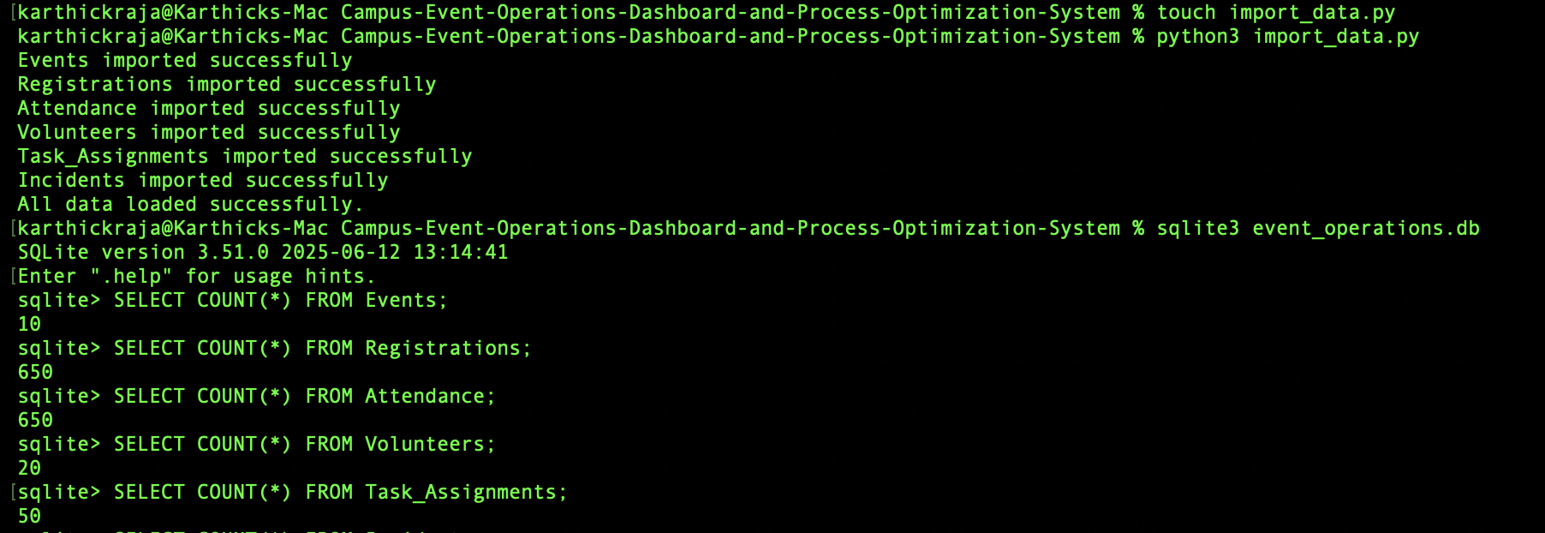

Observation
Table | Record Count
Events | 10
Registrations | 650
Attendance | 650
Volunteers | 20
Task Assignments | 50
Incidents | 40

Conclusion
All datasets were successfully imported into the SQLite database. Record counts matched the expected values generated during the sample data creation phase.

Registration Distribution Validation

Validation Query
SELECT
Event_ID,
COUNT(*) AS Registrations
FROM Registrations
GROUP BY Event_ID
ORDER BY Registrations DESC;
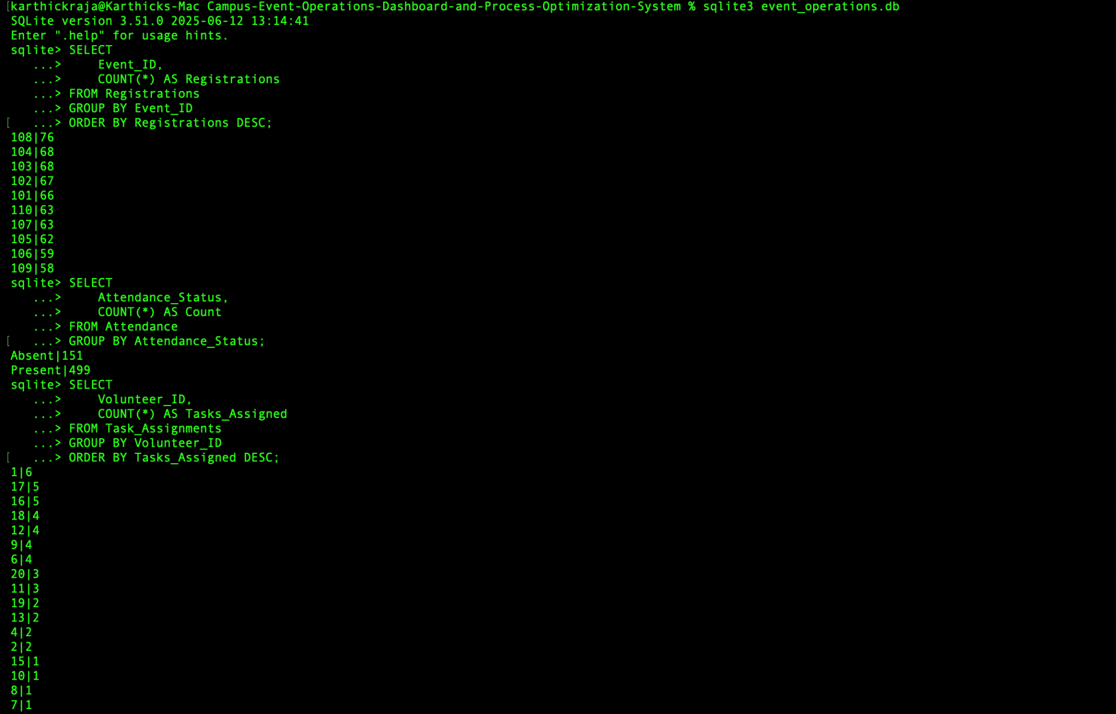

Observation
Event ID | Registrations
108 | 76
104 | 68
103 | 68
... | ...

Conclusion
Registrations were distributed across all 10 cultural events. No event had zero registrations, indicating realistic participant allocation.

Attendance Validation

Validation Query
SELECT
Attendance_Status,
COUNT(*) AS Count
FROM Attendance
GROUP BY Attendance_Status;

Observation
Status | Count
Present | 499
Absent | 151

Calculation
Attendance Rate: 76.77%
Absentee Rate: 23.23%

Conclusion
Attendance rates closely match the project's target assumption of approximately 78% attendance and 22% absenteeism.

Volunteer Workload Validation

Validation Query
SELECT
Volunteer_ID,
COUNT(*) AS Tasks_Assigned
FROM Task_Assignments
GROUP BY Volunteer_ID
ORDER BY Tasks_Assigned DESC;
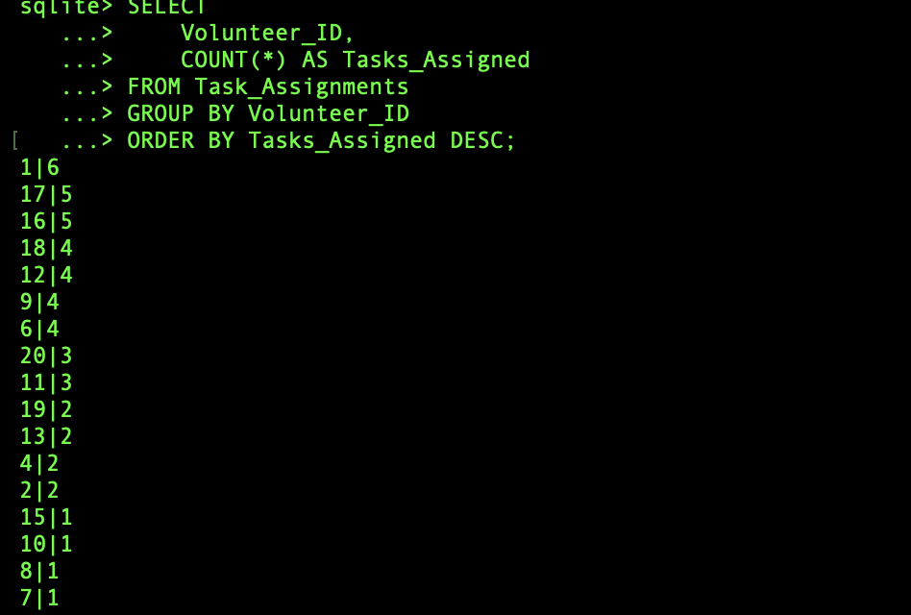

Observation
Volunteer ID | Tasks Assigned
1 | 6
17 | 5
16 | 5
... | ...

Conclusion
Tasks were distributed among volunteers. No volunteer was overloaded, and workload allocation appeared balanced across the volunteer pool.

Incident Distribution Validation

Validation Query
SELECT
Incident_Type,
COUNT(*) AS Total
FROM Incidents
GROUP BY Incident_Type;
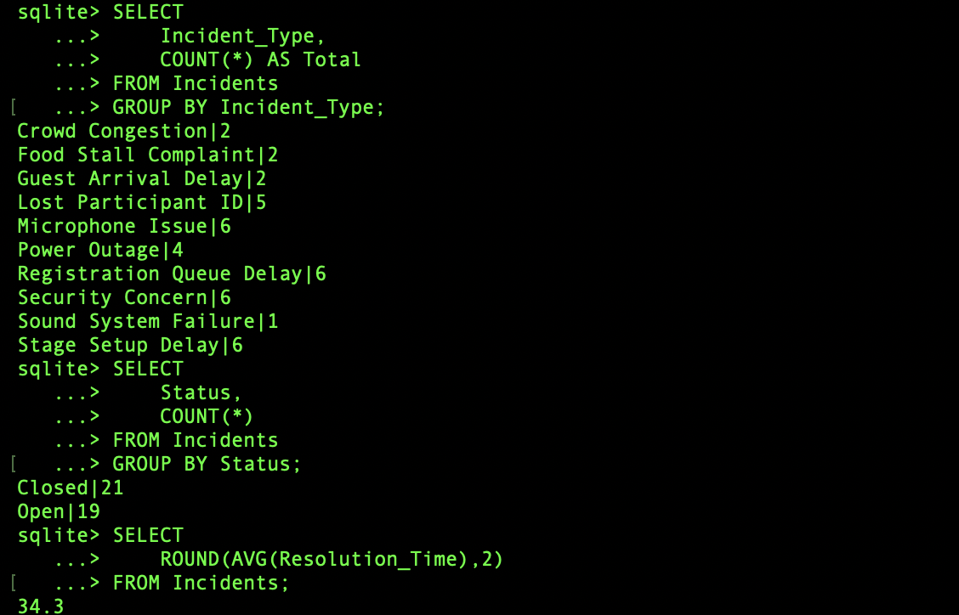

Observation
The most common incidents were:
- Microphone Issue
- Registration Queue Delay
- Security Concern
- Stage Setup Delay
Each with approximately 6 occurrences.

Conclusion
Incident records were diversified across multiple operational categories, providing realistic operational risk data for future dashboard analysis.

Incident Status Validation

Validation Query
SELECT
Status,
COUNT(*)
FROM Incidents
GROUP BY Status;
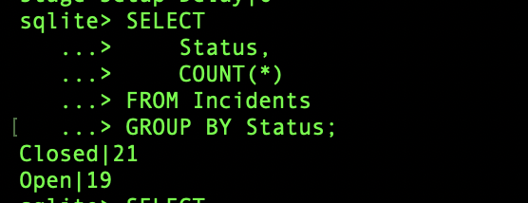

Observation
Status | Count
Closed | 21
Open | 19

Conclusion
Incident records contain both active and resolved cases, enabling future analysis of issue resolution performance.

Resolution Time Validation

Validation Query
SELECT
ROUND(AVG(Resolution_Time),2)
FROM Incidents;


Observation
Average Resolution Time:
34.30 minutes

Conclusion
The average resolution time falls within the expected operational range and can be used as a KPI for incident management performance.

Overall Validation Summary
Validation Area | Status
Data Import Validation | Passed
Registration Validation | Passed
Attendance Validation | Passed
Volunteer Allocation Validation | Passed
Incident Distribution Validation | Passed
Resolution Time Validation | Passed

Final Assessment
All generated datasets were successfully imported and validated. The database is ready for Week 3 activities involving KPI analysis, SQL reporting, and dashboard development.

